**Project 1 : Historical Stock Data**

Problem Statement : There is a list of 161 stocks in excel file, you have to find closing price for these stocks for last 30days.

Solution :

Import all the necessary libraries:

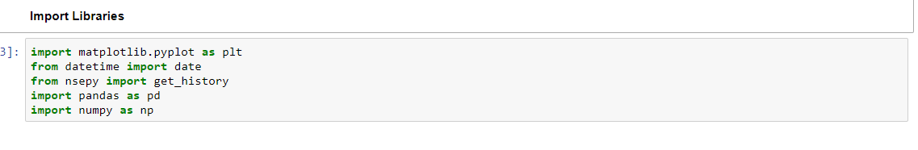

Loading the dataset which contains labels of the stocks:



Covert the column into list so that we can easily copy label names:



We will import the NSEpy library for stock data:



Make a list of the 161 symbols and then convert it into a dataframe:



Using a for loop we will iterate to each of the symbols and print the closing rates all together:



Now we have successfully printed closing prices of these 161 stock files

Output: 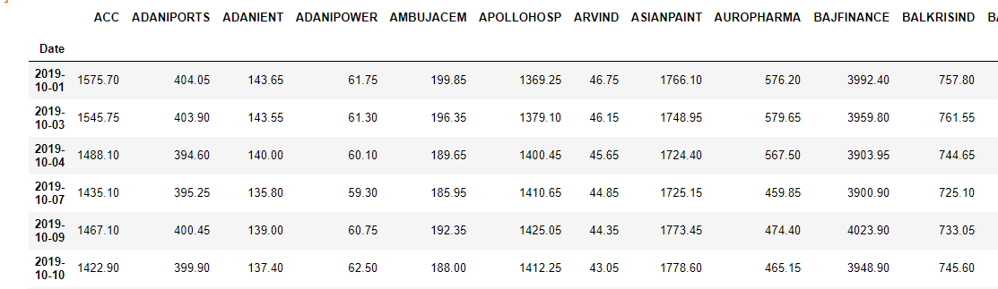

Now will will check for any missing values:



Here we can see that NSEpy does not have any information about 'PVR' so we will drop that column:

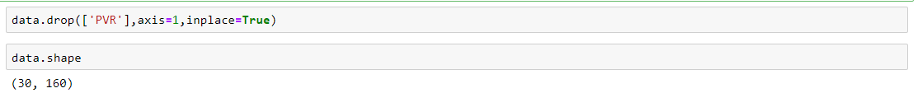

We will manually download the closing price for 'PVR' from www.nseindia.com for the last 30 days:

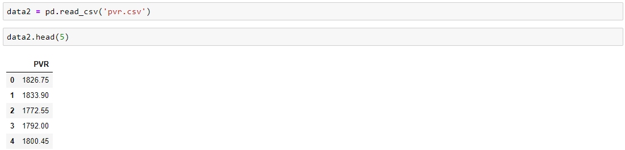

We will append these values into our original dataset containing closing rates of 160 stocks:



So now we have the complete output of all the closing prices of 161 given stocks for the last 30 days.

Output:

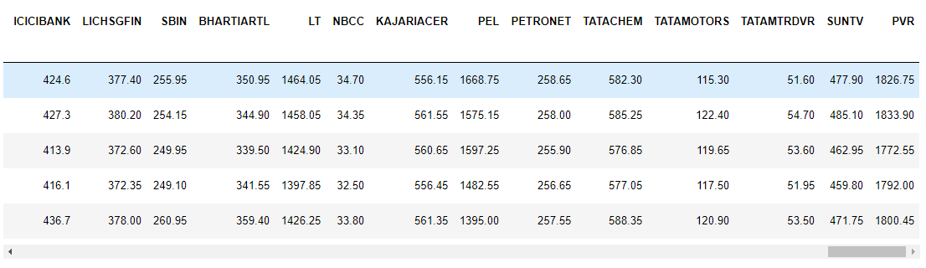

Now we will export the data into excel:



We will try to plot 5 stocks:

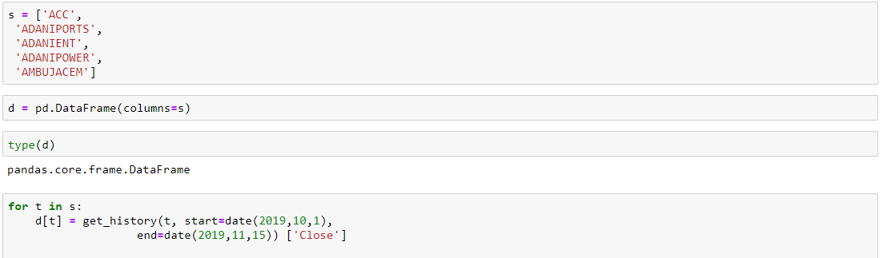

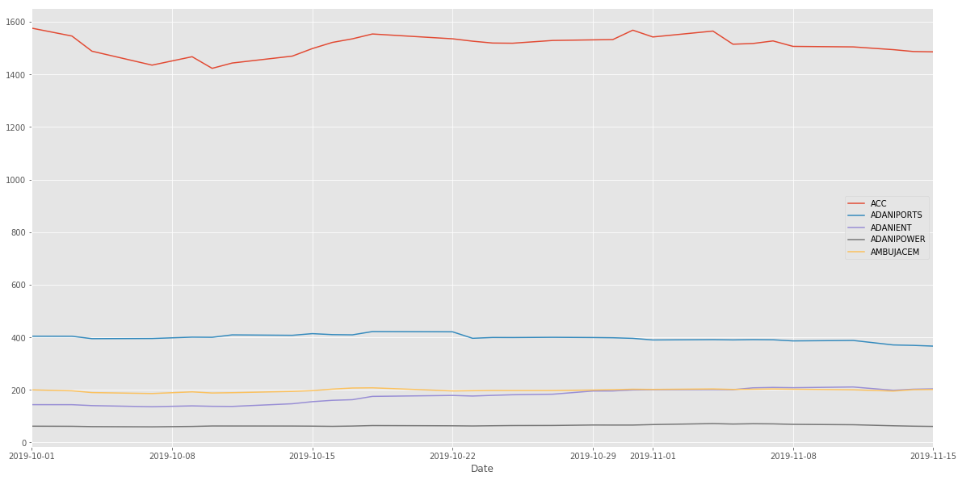

Findings and Conclusion :

Here we can conclude that NSEpy is a very good API for fetching historical stock prices of Indian Market. It has a huge collection dating back to as far as 1997. It can be used as a free source for backtesting in stock market prediction techniques.